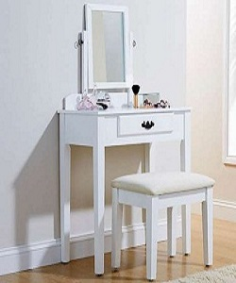

Poliform Dressing Table

$117.64

Availability: In stock

**Description:**

Luxury and glamour Polifom Dressing table. Designed with a lavish modern style, is a chair with special light shapes. Available in different size. The finish and contemporary design are adaptable for any decor style. It is perfect to prepare yourself for a day of work or important date at night. One storage drawer provide sample hidden storage space for small items. Available with us at highly affordable market prices, these Dressing table are available in customers stated specifications.